Washington Contribution to the 2007 Meeting of the Technical Sub-Committee (TSC) of the Canada-US Groundfish Committee

Compiled by:

Thomas Jagielo
Senior Research Scientist

Washington Department of Fish and Wildlife

April 24th - 25th, 2007

Santa Cruz, California
Review of Agency Groundfish Research, Assessment, and Management

A. Puget Sound Area Activities

2. Puget Sound Groundfish Monitoring, Research, and Assessment (Contributed by Wayne Palsson, Marine Fish Science Unit (425) 379-2313, palsswap@dfw.wa.gov)

Staff of the Puget Sound Marine Fish Science Unit includes Wayne Palsson, Robert Pacunski, Tony Parra, Jim Beam, and Ocean Eveningsong. Their tasks are primarily supported by supplemental funds from the Washington State Legislature for the recovery of Puget Sound bottomfish populations. Most of the work of the staff is associated with the Puget Sound Assessment and Monitoring Program (PSAMP) and is tasked by the Puget Sound Action Team. The main activities of the unit include the assessment of bottomfish populations in Puget Sound and the evaluation of bottomfish in marine reserves. This year, additional grants and contracts were received for special studies regarding marine fish habitat modifications and marine reserves in Puget Sound.

A major effort was undertaken this year to develop a conservation plan for rockfishes in Puget Sound.

Evaluation of Rockfish Populations in Puget Sound
Staff continued reviewing the biology, ecology, fisheries, stressors, and status of rockfishes in Puget Sound. The Washington Department of Fish and Wildlife manages the 27 species that have been recorded in Puget Sound and manages the various commercial and recreational non-tribal fisheries that have either targeted rockfishes or have caught them incidentally to other targeted species. Rockfishes and other groundfish are managed for non-tribal users under the auspices of the Puget Sound Groundfish Management Plan and are co-managed with the Treaty Tribes of Washington. The technical review is to be a companion to the Conservation Plan for rockfishes in Puget Sound mandated by the Puget Sound Groundfish Management We summarize current knowledge of Puget Sound rockfish biology (life history, habitat usage, and ecosystem linkage) and provide an overview of their exploitation history and population status in 2006.
Because of a lack of complete catch and demographic information, formal stock assessments with retrospective and predictive models could not be conducted. The status of rockfish populations in Puget Sound were evaluated in terms of their vulnerability to extinction and, where appropriate, populations will be evaluated for their fishery potential and biological reference points. To achieve this, information on fishery landings trends, species composition trends, and yield per recruit for nine rockfish species from Puget Sound were evaluated for long-term trends.
The patterns of stocks status were generally similar between North and South among the 17 species of rockfish that were examined. Six populations (19%) of the 32 populations present in either North or South Sound were in Healthy Status. Twelve populations (38%) were in Precautionary status. Only one population in North Sound was in Vulnerable status, and seven populations (22%) were in Depleted status. Six populations (34%) were in Unknown status with five of these in North Sound.
The pattern of stock condition is related to the frequency of the species in the catch with more common species being in poorest condition and those smaller and deeper species that are seldom caught being in the healthiest conditions. Copper and quillback rockfishes have been the two most important species in the recreational fishery, and both were in depleted or vulnerable status in both North and South Puget Sound. Yelloweye and canary rockfishes are also depleted but were always uncommon in Puget Sound catches but have been overfished in coastal waters. Five species in North Sound and six species in South Sound were in precautionary status, and these species such as black, yellowtail, and bocaccio have been secondary species of importance in recreational and commercial fisheries. Black rockfish in the western portion of the Strait of Juan de Fuca are a special exception to the overall precautionary status, perhaps because this area is fed directly by spillover from coastal areas. Populations of brown rockfish in South Sound are another exception: This population is healthy but generally not present in the recreational catches. Other healthy populations include the deepwater redstripe, greenstriped, and shortspine thornyheads, all species that appear to be uncommon or rare in inspected catches. The status of six populations was unknown with most of these in North Sound. These species are rare in catches and include tiger, China, Blue, brown, and splitnose rockfishes in North Sound and tiger rockfish in South Sound. Several species are generally not detected in South Sound including China and blue rockfishes in South Sound. Vermilion rockfish appear to be invading Puget Sound from coastal waters but their status is Precautionary until more assessment information is developed.
The results of this review are being integrated in the Conservation Plan for Rockfishes in Puget Sound. The current status and fishery patterns strongly suggest more extreme conservation measures will be required to stabilize rockfish populations and to promote their recovery.

Puget Sound Marine Habitat Studies
Wayne Palsson and Robert Pacunski continue to collaborate with Professors Don Gunderson of the University of Washington and Gary Greene of Moss Landing Marine Labs. A Washington Sea Grant study is being conducted to examine the distribution of marine fishes in relation to the distribution of different sea floor habitats in the San Juan Archipelago. The San Juan Channel was mapped with a high-resolution multi-beam echosounder that collected detailed bathymetric and back-scatter information (Figure 1). This mulitbeam bathymetry and bottom type information provided the survey frame for the Sea Grant study. During the 2004 field season, we used a Phantom 2+2HD ROV to survey the diversity of rocky, coarse, and fine sediment habitats in San Juan Channel. We found strong community associations with each substrate type. As expected, rockfish and lingcod were almost exclusively associated with rocky habitats. During the second year of study in 2005, we conducted 87 ROV transects in San Juan Channel and focused exclusively on rocky habitats to tease apart exactly how rockfish and lingcod are associated with different rocky habitat features. As in 2004, we were successful in deploying the ROV with a depressor weight and conducting transects as deep as 500 feet and in current speeds of 1.5 knots. Data are being analyzed and written up for peer-reviewed publications.

A Remarkable Settlement of Young-of-the-Year Rockfishes in Puget Sound and the Strait of Juan de Fuca in 2006 (Contributed by: LeClair, Buckley, Palsson, Pacunski, Parra, Eveningsong, Beam, McCallum).
During 2006, we investigated a remarkable settlement of post-larval rockfishes in the inland marine waters of Washington. Quantitative scuba transects were conducted to determine how young-of-the-year rockfishes used nearshore habitats and how this use changed with time and growth. Two major patterns of recruitment were observed. In Puget Sound, high densities of copper and quillback rockfishes were observed in nearshore vegetated habitat including attached floating and submerged kelp. Lower densities were observed in eelgrass during the early summer. These post-settlement fish initially measured between 20 mm and 40 mm in length, increasing to near 80 mm by early fall when their habitat associations changed. Genetic identification using microsatellite loci was used to confirm the species composition of sampled juveniles.

The other pattern in rockfish settlement was observed in the Strait of Juan de Fuca where unusually large schools of rockfishes were observed in September at both the eastern and western ends of the strait. The species composition of these schools was different and more varied than those observed in Puget Sound.

Low Dissolved Oxygen Conditions at Sund Rocks Marine Reserve
Hood Canal is a fjord connected to Puget Sound in the north and extending 100 km to the south. The steep sides of the canal extend to depths of 180 m in the north and range to depths of over 125 m for most of the water body. Hood Canal is one of the water bodies identified in the Pew Ocean Commission report as a hypoxic dead zone. Dissolved oxygen (DO) concentrations of less than 2 mg/l have been observed for decades in deep and shallow waters in the southern portion of the canal, and these low concentrations have been attributed to naturally poor circulation resulting from low estuarine flow and bottom water replacement. In recent years, low DO concentrations have become chronic, extending into nearshore waters and possibly becoming worse due to eutrophication (J. Newton, Hood Canal Dissolved Oxygen Program). Mass mortality events of fishes and invertebrates (Fish Kills) in 1926 and 1963 likely have resulted from poor water quality.

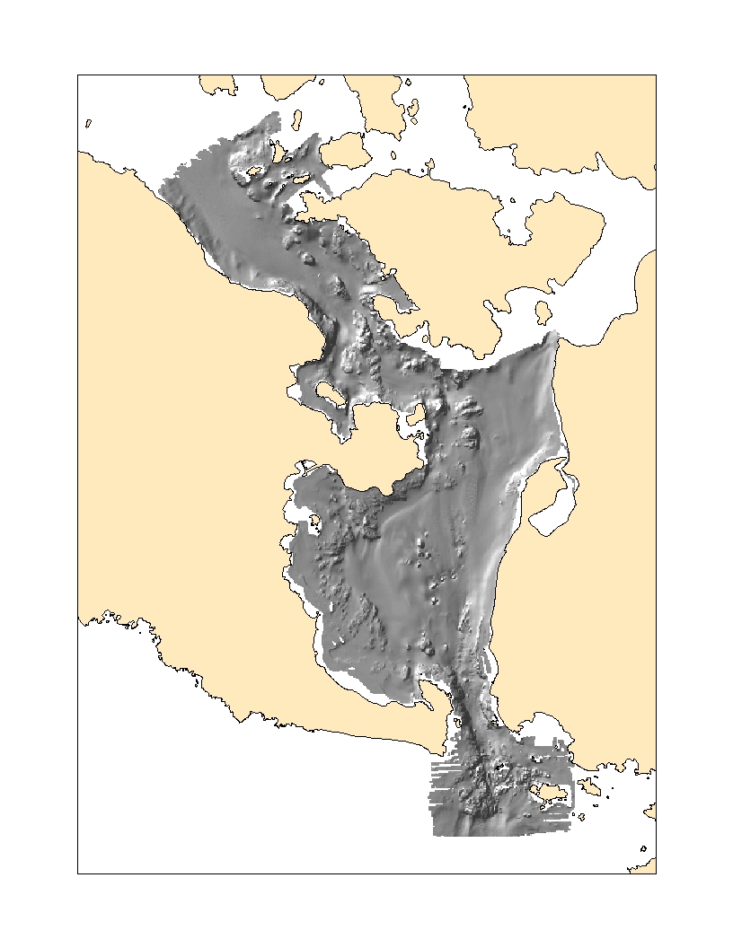
Figure 1. Hillshaded bathymetry of San Juan Channel.

Beginning in 2001, WDFW began surveying marine fishes with respect to depth at the Sund Rocks Reserve. As chronic and episodic hypoxia events developed beginning in 2002, the marine reserve study changed into one on the effects of hypoxia on marine fishes. The goal of this study is to examine the water quality thresholds that initiate avoidance behavior and the conditions that lead to fish kills. Two discrete and prominent rocky habitats located north and south of Sund Rocks Conservation Area were surveyed independently. A team of three divers conducted the visual surveys. One diver swam the 9 m isobath and oriented the two recording divers along the longitudinal axis of each survey area. The two divers swam along predetermined depth zones and identified, counted, and measured key fish species along the rocky outcropping. The divers swam close together to coordinate their observations and not double count fishes. Total length measurements to the nearest 10 cm were made with the aid of a graduated plastic rod. Beginning in Fall 2005, WDFW divers also collected data on temperature, salinity, and oxygen concentrations with a probe on the same days of their scuba surveys.

Dive surveys at both the North and South Sund Rocks sites in November 2001 found that copper rockfish were distributed evenly from a depth of 5 m to a depth of 20 m and were generally not present in depths of less than 5 m. Monthly monitoring by WDOE revealed that DO concentrations were at least 3 mg/l in waters shallower than 20 m. In October 2002, we found rockfish were almost exclusively concentrated in depths of less than 7 m during a period when DO concentrations were greater than 4 mg/l in shallow water and less than 2 mg/l at greater depths. Rockfish were distributed evenly to 20 m in depth again by November 2002 when rains restored circulation and DO concentrations were once again greater than 4 mg/l in the nearshore zone.

During the 2002, 2004, and 2005 low DO events, dead fish were not observed at Sund Rocks. However, during 2003 and 2006 major fish kills were observed along the western edge of southern Hood Canal and at Sund Rocks. These events had marked differences in the biomass of fishes killed. In 2003, the greatest biomass of dead fish were copper rockfish while in 2006 the greatest biomass was lingcod with very few rockfish. We estimated that one third of the copper rockfish at the site died due to hypoxia in 2003 and one third of the lingcod died in 2006.
These field observations revealed that copper rockfish are hypoxia intolerant and cannot tolerate DO concentrations below 1 mg/l. The observed avoidance behavior is triggered when DO concentrations range between 2 and 3 mg/l. The widespread occurrence of poor water quality in southern Hood Canal has many ramifications for sustainable fisheries pursued by tribal and recreational fishers and for the location and design of marine reserves in the area. Further work is planned for determining the causes of worsening water quality and the impact on marine resources.

Second Tacoma Narrows Bridge Mitigation Study
In March 2003, the Washington Department of Transportation (WSDOT) and the Washington Department of Fish and Wildlife (WDFW) established a contract to fulfill part of the terms of the mitigation agreement for the construction of a second bridge at Tacoma Narrows, connecting Tacoma with the Kitsap Peninsula across Puget Sound. The contract establishes that staff from WDFW will conduct sampling at the bridge site to determine the impacts of the disruptive activities associated with the construction of the bridge upon marine fish communities at the bridge site. Primary areas of interest include the two caisson and pier sites, the proposed anchor sites, and the rip-rap fields that will be placed at the footings of the existing and new tower piers. As part of the mitigation, a new artificial habitat was created at Toliva Shoal in spring 2005 that tested the effectiveness of adding small, quarried rock on or near existing artificial habitat composed of large boulders and concrete deployed for attracting adult rockfish (Figure 2).

Monitoring at the bridge site included conducting scuba transects in the shallow waters (<100 ft) at planned anchor sites and conducting towed video transects at planned anchor, rip-rap, and bridge tower locations. Pre-construction surveys revealed that most rockfish and lingcod were distributed along old bridge rubble and natural hardpan habitats on the eastern side of the Narrows. Now that the towers have been erected and the anchors removed, after-construction comparisons will be made from transects conducted during early 2006.

Pre-construction scuba transects at Toliva Shoal, found that most rockfish and lingcod were sparsely distributed on previously deployed, large-rock artificial habitats composed of concrete and quarried boulders. Initial surveys after deployment of small, quarried rock found sub-adult rockfish sparsely distributed on newly created habitat in greater numbers than on comparable transects that were not affected by new construction. Extensive surveys will continue for the next two years to determine the effectiveness of creating a small rock habitat for rockfishes on top of or away from an existing artificial habitat composed of large rocks targeting adult rockfish and lingcod. During 2006, a massive recruitment of young rockfish were observed in the nearshore vegetated habitats of central and southern Puget Sound. However, there were no young-of-the year observed at the artificial habitats at Toliva Shoal upon initial recruitment but a few were observed later in Fall 2006. Hundreds of YOYs were observed at inshore habitats near Toliva Shoal suggesting that offshore habitats are not as important as nearshore habitats for the recruitment of settling rockfish. We did observe higher numbers of sub-adult rockfish after reef construction suggesting these offshore habitats may support a post-recruitment settlement.

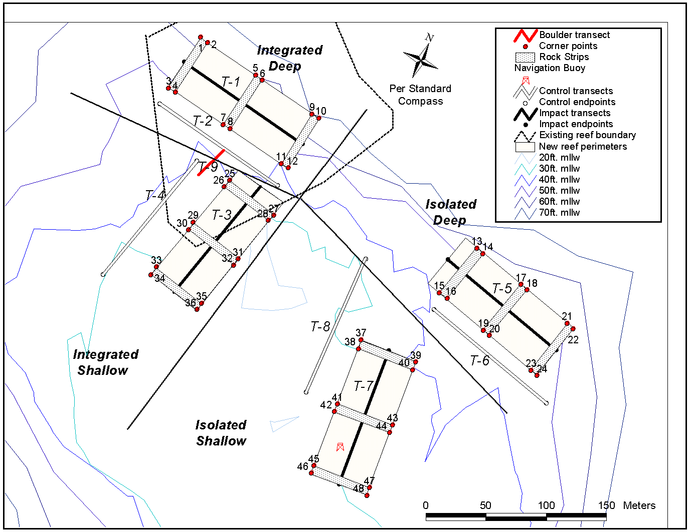
Figure 2. Deployed quarry rock for juvenile rockfishes at Toliva Shoal.

Bottom Trawl Surveys of Puget Sound
Since 1987, WDFW has conducted bottom trawl surveys in Puget Sound that have become invaluable as a fisheries-independent indicator of population abundance for fishes living on unconsolidated habitats. The trawl surveys have been conducted at irregular intervals since 1987 but more recently have focused extra effort in individual sub-basins to improve regions specific confidence intervals. The goals and objectives of the current surveys are to estimate the abundance and describe the distribution of recreational and commercial groundfish and macro-invertebrate species, collect biological information from key species, and evaluate the relationship of abundance and distribution of key species to oceanographic features. During 2006, we surveyed the U.S. Strait of Georgia and the San Juan Archipelago as well as processed information collected from the 2005 survey of Puget Sound. The chartered F.V. Chasina is as the sampling vessel which tows a 400 mesh Eastern net fitted with a 3 cm codend liner. Stations are selected with a stratified random approach based upon four depth zones for each of the subregions. The area sampled at each station is measured with differential GPS and known net width openings. The catch from each trawl was identified, weighed, and enumerated, and the weights and numbers of each species are divided by the area sampled to estimate species densities. Abundance is estimated by averaging station densities within each stratum and multiplying these by the stratum area. A total of 40 to 50 trawl stations were occupied in each sub-basin.

3. Herring Stock Assessment (Contact: Kurt Stick (360) 466-4345 ext. 243)

Annual herring spawning biomass is estimated for known herring populations in Washington waters using spawn deposition and/or acoustic-trawl surveys. The Washington Department of Fish and Wildlife (WDFW) recognizes nineteen different herring stocks in Puget Sound and two coastal stocks, based primarily on timing and location of spawning activity. WDFW Region 4 staff based in the Mill Creek and La Conner offices attempts to conduct spawn deposition and/or acoustic-trawl surveys of all herring populations in Washington annually. Stock assessment activities for the 2007 spawning season are in progress.
The herring spawning biomass estimate for all Puget Sound stocks combined in 2006 is 17,765 tons (see table and figure below). The cumulative total is slightly higher than the 2001 and 2002 estimates and considerably higher than the 2003-2005 estimates. The Puget Sound total reflects a general increase in the combined biomass of south/central Puget Sound (including Hood Canal) stocks since the early 1990’s.
Cumulative biomass of North Puget Sound stocks has remained at a low level of abundance, primarily due to the continued critical status of the Cherry Point herring stock. The Cherry Point stock increased slightly in 2006 to 2,216 tons, continuing an observed annual increase since a low of 808 tons in 2000. The Cherry Point stock ranged from 3,100 to nearly 15,000 tons between 1973 and 1995.

The Discovery Bay herring stock is the primary component of the Strait of Juan de Fuca region. The estimated spawning biomass in 2006 of 1,325 tons for this stock was the highest observed since 1987.

No spawning activity was observed in 2006 for coastal stocks (Willapa Bay and Grays Harbor). In general, herring spawning biomass for these areas is relatively small compared to Puget Sound.

4. Puget Sound Ambient Monitoring Program (PSAMP) (Contact: Sandie O'Neill (360) 902-2843)

The Washington Department of Fish and Wildlife continues to be a key component of the Puget Sound Ambient Monitoring Program Project (PSAMP), a multi-agency effort to assess the health of Puget Sound. To assess how the health of the Sound is affected by chemical contamination of it’s fish, the PSAMP Fish Component monitors “legacy” pollutants like PCBs and DDTs that persist in the ecosystem despite restrictions in their use, PAHs, which are compounds associated with petroleum and with combustion, heavy metals, and emerging toxics like PBDEs that are used as flame retardants.

5. Puget Sound Marine Fish Research (Contact: Larry LeClair, Marine Fish Science, 360 902-2767, leclalll@dfw.wa.gov)

Trans-generational Marking of Viviparous Marine Fish in Puget Sound, Washington
Investigators at the Washington Department of Fish and Wildlife continued experimenting with the use of elemental strontium as a means to mark the otoliths of viviparous marine fish larvae prior to birth. Laboratory trials with captive perch and rockfish have shown that a single intramuscular injection of strontium into gestating adults is sufficient to produce a lifelong strontium mark in the otoliths of larvae prior to parturition, thus providing a potential method for directly estimating retention and dispersion rates from local populations.

Field trials are now underway at Point Heyer, Washington with brown rockfish (Sebastes auriculatus). To date, 139 gestating females have been injected and released in situ, and more than 300 injection cohort juveniles have been recovered. A single marked otolith has thus far been found among the 150 juveniles assayed to date. The upcoming year will focus on juvenile recoveries from the last injection cohort and the completion of strontium assays. Preliminary results will appear in a 2007 Sea Grant publication on the biology, assessment, and management of north Pacific rockfishes.

Use of Microsatellite DNA and Pedigree Analysis to Test For Self-recruitment in an Isolated Population of Brown Rockfish in Puget Sound, Washington
This collaborative study between the Washington Department of Fish and Wildlife and the University of Washington is aimed at using genetic markers to identify progeny of resident adult brown rockfish among juveniles sampled at an isolated reef near Point Heyer, Washington. Non-lethal in situ sampling using tissue clipped from the dorsal lobe of the caudal fin are being used to genotype individuals at 12 microsatellite loci. To date, 137 adults, estimated to be about one third of the total adult population, have been sampled and genotyped. Genotypes from 118 juveniles have been obtained. Preliminary results using a maximum likelihood estimation approach indicate self-recruitment to be about 15%; however, low genetic variability and higher than expected genotyping error has lead to some ambiguity in assigning parent-offspring-sib relationships. Additional marker loci with greater allelic richness and reduced genotyping error were developed in 2006 and will be used to assay existing and future collections from Point Heyer and adjacent areas. Results are expected to be directly applicable to the design and placement of MPA’s in Puget Sound and elsewhere. The upcoming year will focus on collecting oceanographic data during the larval release season to develop a model for larval dispersal distance and trajectory from Point Heyer. Field sampling and genotyping of adult and juvenile brown rockfish will continue. Preliminary results will appear in a 2007 Sea Grant publication on the biology, assessment, and management of north Pacific rockfishes.

Allozyme and Microsatellite DNA Analysis of Lingcod From Puget Sound, Washington, and Adjoining Waters
Allozymes and microsatellite DNA were used to examine genetic connectivity among lingcod populations in Puget Sound and between Puget Sound and the outer coast. No significant differences in allele frequencies were detected, though multidimensional ordination suggested minor differences between Puget Sound and the outer coast. Results of the study appeared in the Transactions of the American Fisheries Society, 2006, 135:1631-1643.

Efficacy of PIT tags to monitor movements of juvenile rockfish in Puget Sound.
Passive integrated transponder (PIT) tags are being evaluated for efficacy of in situ monitoring of early life history stage rockfish. Underwater injection and detection techniques are being developed and studies are underway with captive juveniles at local aquariums to determine the lowest fish length limits, tag retention, and survival.

B. Coastal Area Activities

1. Coastal Groundfish Management (Contact Michele Culver, (360) 249-1211 or Brian Culver, (360) 249-1205)

Council Activities
The Department contributes technical support for coastal groundfish management issues via participation on the Groundfish Management Team (GMT), the Scientific and Statistical Committee (SSC), and the Habitat Steering Group (HSG) of the Pacific Fishery Management Council (PFMC). The Department is also represented on the Scientific and Statistical Committee and Groundfish Plan Teams of the North Pacific Fishery Management Council. Landings and fishery management descriptions for PFMC-managed groundfish are summarized annually by the GMT in the Stock Assessment and Fishery Evaluation (SAFE) document.

2. Coastal Groundfish Monitoring, Research, and Assessment

Black Rockfish Tagging Study Contact: Farron Wallace (360) 249-1207
In 1998, WDFW began a multi-year mark-recapture survey near Westport Washington, the principal location of recreational landings of black rockfish along the Washington coast. The survey design involves annual releases of coded wire tagged (CWT) fish and recovery of tagged carcasses from the recreational fishery, both of which are currently on going. From 1998 to 2001, WDFW’s R/V Corliss was used to capture, tag and release 2,622, 3,478, 2,779 and 3,200 black rockfish annually. Since 2002, commercial charter vessels have been used, including F/V Hula Girl, F/V Slammer and F/V Tequila Too. A total of 4,089 black rockfish were caught, tagged and released in 2002, 6,744 in 2003, 5,981 in 2004, 3,940 in 2005 and 6289 in 2006. In 2004, passive integrated transponder (PIT) tags were used to reduce the labor needed to read and match recovered tags. In 2005, all tagged fish released were tagged with both CWTs and PIT tags, which will allow estimation of PIT tag loss rates (since CWT loss rates are already known). Tag detection experiments in 2006 indicated that detection of PIT tags during high volume recovery where fish are in the detectors range for less than a second was less than 60%. CWT tag detection was over 95%. Due to this, PIT tags have been excluded from tag releases in 2007.

Fish are released on pinnacles distributed throughout the area fished by the Westport charter fishing fleet. Each CWT tagged fish had two tags placed in the opercular musculature; one on each side of each fish’s head. The tags were marked to allow for identification of specific individuals upon subsequent recapture. No tag shedding or tag related mortality was observed during holding experiments during 1998, 1999 and 2003.

On an annual basis, roughly 40% of the total Westport recreational black rockfish catch is sampled for CWT tags by passing fish carcasses through a metal detector tube (Northwest Marine Technologies R8000).

Cooperative Rockfish Sampling Survey (Yuk Wing Cheng¹, Claude Dykstra², Tien-Shui Tsou¹, Bruce Leaman² and Brian Culver¹; ¹Washington Department of Fish and Wildlife,
² International Pacific Halibut Commission)

Twenty-seven and twenty-five survey stations targeting halibut and rockfish, especially yelloweye rockfish, were surveyed with longline fishing gear between June and July 2006. The existing halibut stations have been surveyed annually by the International Pacific Halibut Commission (IPHC) since 1998. The twenty-five new rockfish stations were selected based on historical rockfish catch from the IPHC survey stations, the Pacific Coast Groundfish EFH Mapper program, and spot prawn logbook trawling data. We found that the Groundfish EFH Mapper data might not provide a reliable spatial description of rocky areas, or that there was no relationship between rocky habitat and yelloweye abundance. With the addition of yelloweye survey station results, the CV of the 2006 yelloweye abundance index was 38% lower compared with the use of halibut survey station results alone.

Based on the 2006 survey, the estimated Pearson’s product-moment correlation between yelloweye and halibut catches from yelloweye survey stations was 0.37 (P=0.07). The estimated Pearson’s product-moment correlation between yelloweye and halibut catches from halibut survey stations was 0.96 (P<0.001).

Halibut surveys stations 1061, 1068, 1069, 1072, 1076, 1078, 1081-1084, had yelloweye catches during 2002-2006 surveys. Thus, these 10 stations are recommended for use in developing a yelloweye abundance index in the future. Yelloweye survey stations 1501-1511, 1513 –1515 should be surveyed in the future if funding is available. If additional survey effort is available, adaptive systematic stratified sampling can be conducted around station 1082, in order to lower the uncertainty of the developed yelloweye abundance indices.

